**Adding an element**

**innerHTML** is useful when we want to change all the HTML content of an element. But if we want to add something, then it might create some bugs. In those cases when we try to append the whole parent element reloads, even the ones that we didn’t edit.

So, this creates a performance issue. And second issue might be, that if we have an input/form inside the parent element and we wrote something there, during the time of reload they will be lost.

Therefore, we can use the **insertAdjacentHTML** to do this.



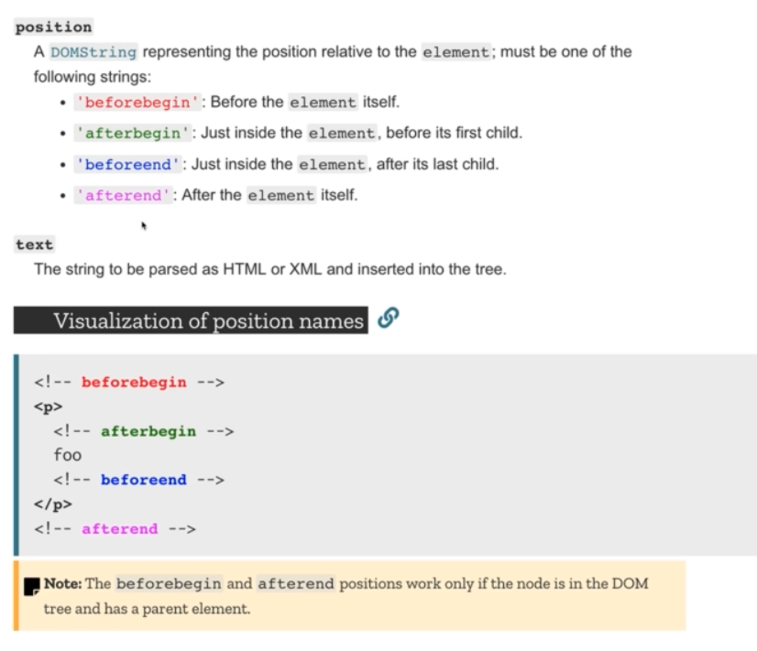

But this also has a downside, we don’t have immediate access to this element. So, if we don’t plan on doing anything with this, this has no problem. But in case we want to use it further, then it will create problem.

So for this reason, it’s better to use **createElement()** method. This will create an element in the Dom but won’t place it anywhere, we will have access to it and can put it anywhere we want.

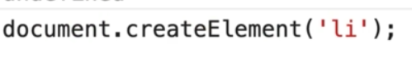

First parameter it takes is the tag, 2nd parameter is almost never used and it’s for custom elements. Then we can use the **appendChild()** to append this and **textContent** to set the text node inside.

**Inserting an element**

* **Inserting an element adjacent to another element**: We can use the insertAdjacentElement() for this. This takes two parameters, position and the element. As we can see we can do different things with it

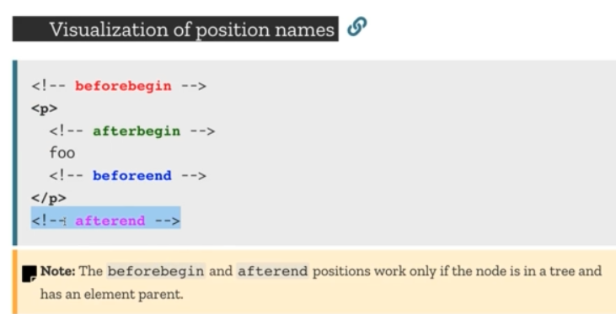

* **Cloning an element:** if we want to copy a node and use it elsewhere. It takes one optional parameter which by default is false. If we pass true there it will take all the siblings of that element, if its false it will only take the direct child.



Older methods on left and newer methods on right, but older methods works on all browsers while new methods might not work on all browsers

